Airsports MSFS2020 Client user manual

Table of Contents

Introduction 1

Installation 2

Usage 2

Sign up as new user 2

Updating your profile 3

Logging in 3

Tracking 3

Known issues 3

# Introduction

Airsports MSFS2020 Client is an application that acts as a bridge between Microsoft flight simulator 2020 and Airsports live tracking. Airsports live tracking is a flight competition tracking platform designed to support live tracking and scoring of precision flying and air navigation races. It is used by flying clubs for national championships several places in the world, and this client brings these contest opportunities to the virtual world.

More information about Airsports live tracking can be found at the lower tracking website <https://airsports.no/>

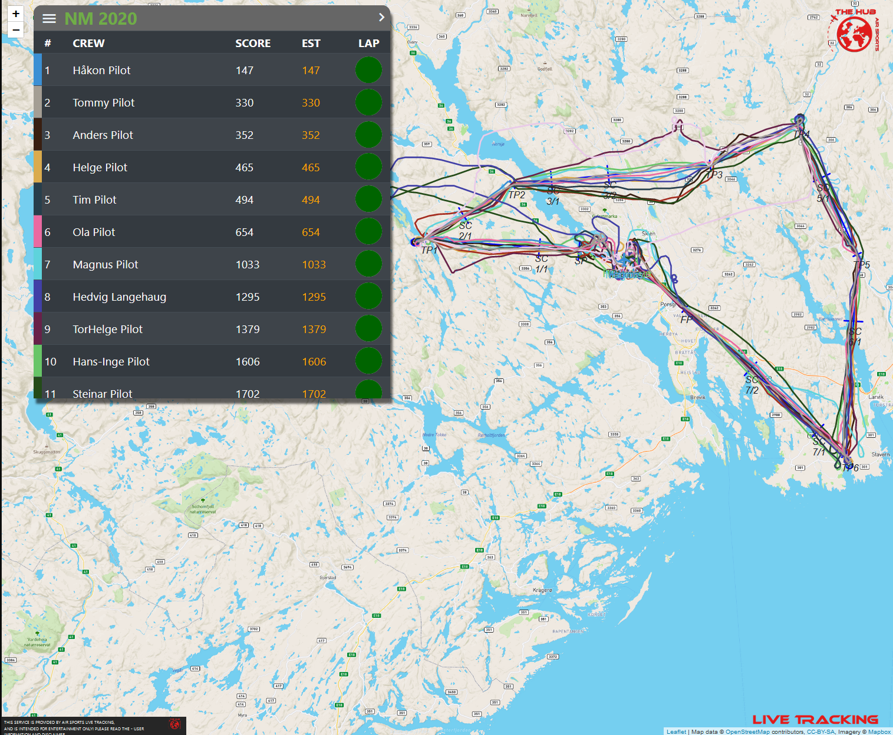

Figure Airsports live tracking competition map

The Airsports MSFS2020 Client allows flights performed in Microsoft Flight Simulator 2020 to compete in the same competition types as real aircraft. This is a companion up to the Airsports live tracking site, and competitions must be configured and set up through a user account on <https://airsports.no>.

# Installation

Airsports MSFS2020 Client is a standalone Python application that is delivered in a zip archive. Installation consists of simply extracting the archive to a location somewhere on the computer. The contents of the archive is two files and a folder, and all three items must be extracted and placed in a single folder on the computer.

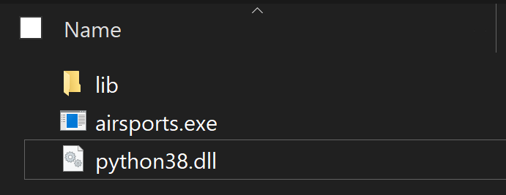

# Usage

Using the application is straightforward, simply double-click the executable file airsports.exe. This brings up a basic user interface that allows an existing user to log into the live tracking system, sign up a new user, and control the transmission of aircraft positions to the live tracking competition system.

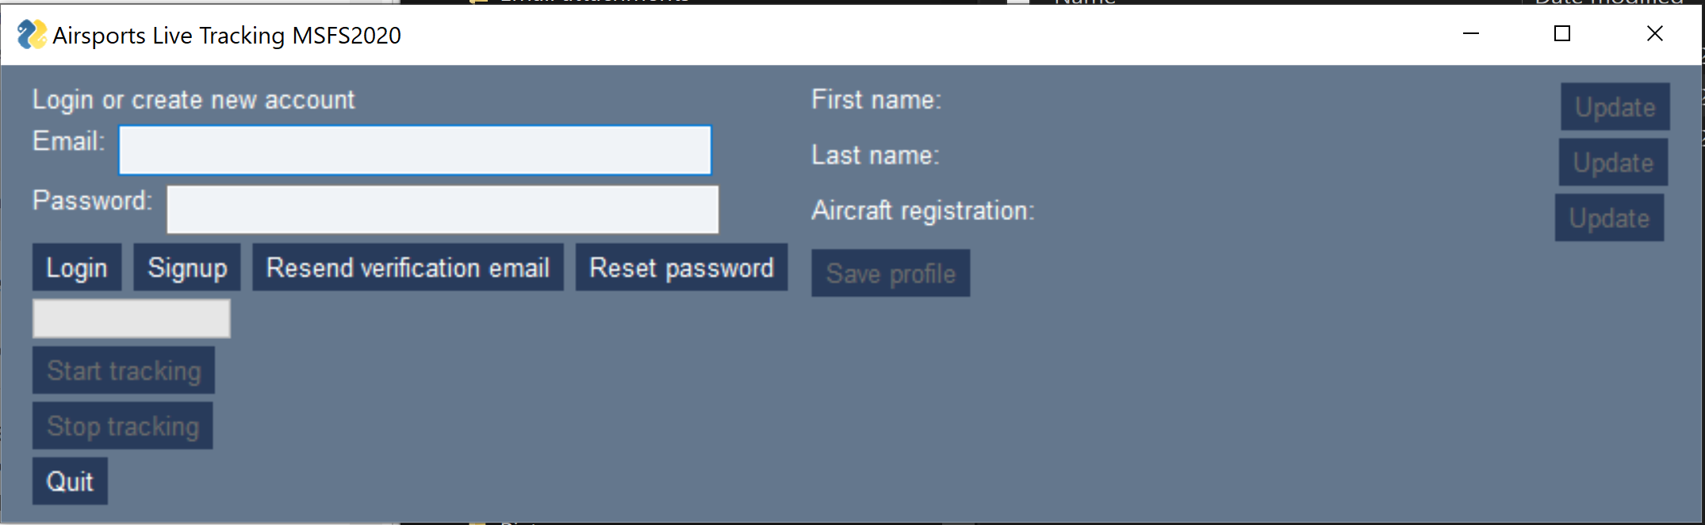

Figure Main application window

## Sign up as new user

The application support signing up as new users in a straightforward manner. Enter an email address and a chosen password in the appropriate email and password fields and click the Signup button. This will connect to the Google Firebase authentication system and create a new user (if the email address does not already belong to a user account). A validation email will be sent to the entered email address, and the links in this email has to be clicked for the account to be validated. If you attempt to login before the email address is motivated, an error message will inform you of this.

If you have not received a verification email, check the spam folder and optionally press the “Resend verification email” button.

After validating the email address, login to the system by pressing the “Login” button.

### Updating your profile

When login in as a new user a new user profile in the live tracking system is created. This user profile is initially locked. This is indicated by a pop-up box when logging in informing you that your profile must be updated. Before this done, the “Start tracking” button which initiates the connection to flight simulator and transmits positions to the live tracking system will be disabled.

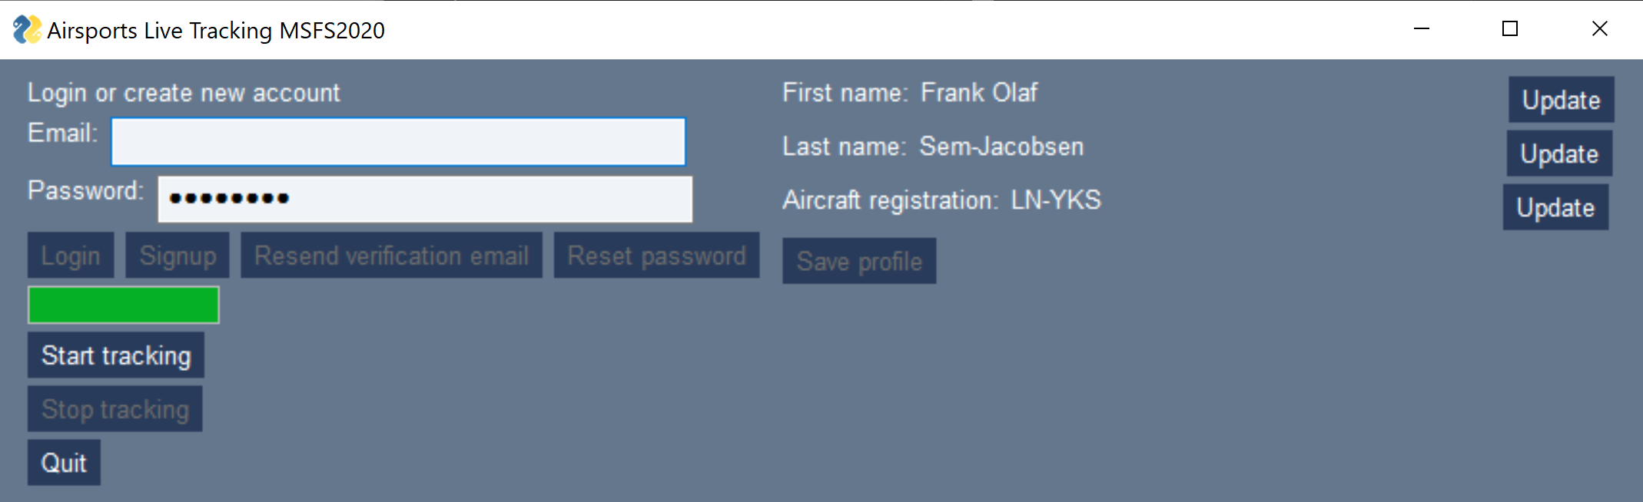

Figure Profile information

Initially the profile information will be empty. And to your first name, last name, and optionally aircraft registration (not required) by clicking on the respective “Update” buttons. After updating a field the “Save profile” button will become available. After clicking this and successfully saving the user profile, initial signup is complete.

## Logging in

Login to the application by entering your email address and password and clicking “Login”. You will be notified if either your email address does not exist in the system, or you have not validated your email. In the first case run the complete signup procedure, in the second case click the “Resend verification email” if you have not received it.

In case you have forgotten your password, enter your email address and click “Reset password”. Follow the instructions in the email that is sent to the email address. If the email address does not exist, sign up as a new user.

## Tracking

After successfully logging in and validating the user profile (if required), you are ready to start tracking. After starting MSFS2020 and spoiling at the desired departure airport, simply click “Start tracking”. The application will connect to the flight simulator, or display an error message if connection failed. The string “Connecting…” will be replaced with the timestamp of the latest position sense to the tracking system. If this continues to increase, precision reporting is working as it should. Determine the tracking either click “Stop tracking” or close the application.

# Known issues

* You have to login with email address and password every time the application starts, this information is not remembered.